# Publishing Settings for Captivate

### SCORM Publish Settings

SCORM publish settings are required for upload and progress tracking in JADL ILIAS Learning Management System.

1. In Captivate, select File > Publishing Settings…
2. Under ‘Quiz’ section, select ‘Reporting’
   1. Check ‘Enable reporting for this project’
   2. In the ‘LMS’ dropdown, select ‘Other Standard LMSs’
   3. In the ‘Standard’ dropdown, select ‘SCORM 1.2’ (best compatibility option for ILIAS)
   4. Next to ‘Standard’, select ‘Configure’ button
      1. Provide ‘Course Identifier’ (no spaces or special characters, ex: ADL213)
      2. Provide ‘Course lesson Title’
      3. Provide ‘SCO Identifier’ (no spaces or special characters, ex: ADL2130101)
      4. Provide ‘SCO Title’
      5. Select ‘OK’ to close windows
   5. In the ‘Template’ dropdown, select ‘Default’
   6. Under ‘Status Representation’, select ‘Incomplete 🡪 Complete’
   7. Under ‘Success/Completion Criteria’, select ‘Slide views and/or quiz’
      1. If there is NO assessment for the SCO, select ‘Slide views’, ‘100%’
      2. If there is a graded assessment, select ‘Quiz’, ‘Quiz Passed’
   8. Under ‘Data To Report’, select ‘Percentage’
   9. Leave ‘Interaction Data’ checked
   10. Under ‘LMS Initialization Text’, enter ‘Loading’
   11. Select the ‘Advanced’ button
       1. Check ‘Send Resume Data’
       2. Check ‘Set exit to normal after completion’
       3. Check ‘Escape Version and Session ID’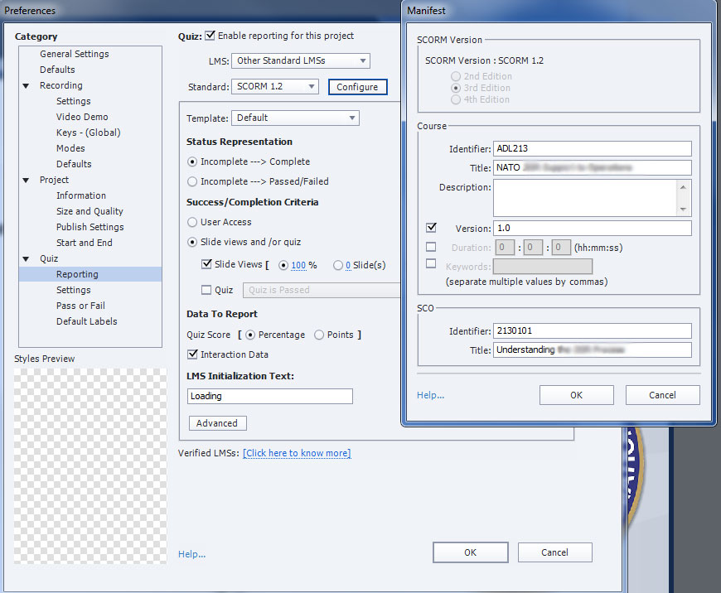Select ‘OK’
3. Under ‘Quiz’ section, select the ‘Settings’ menu
   1. Provide unique ‘Objective ID’ identifier (ex: QuizADL2130101)
   2. Check ‘Allow Backward Movement’
4. Under ‘Quiz’ section, select ‘Pass or Fail’
   1. For pass/fail options, recommend ‘80’ % or more of total points to pass
   2. Check ‘Show Retake Button’

### Quality Publishing Settings

1. In Captivate, select File > Publish Settings…
2. Under ‘Project’ section, select ‘Size and Quality’
   1. Uncheck ‘Retain Slide Quality Settings’
   2. In the ‘Bmp’ dropdown, set to ‘High (24 bit)’
   3. Check ‘Advanced Project Compression’
   4. Check ‘Compress SWF File’

### Final project publishing

1. In Captivate, Select File > Publish…
2. In the ‘Publish’ dropdown, select ‘HTML5/SWF’
3. Provide a ‘Project Title’ (no special characters or spaces ex: 2130101)
4. Provide a ‘Location’ path
5. Check ‘Zip Files’
6. Under ‘Output Format’, select only ‘HTML5’ buttons
7. Uncheck all other options
8. Select the ‘Publish’ button 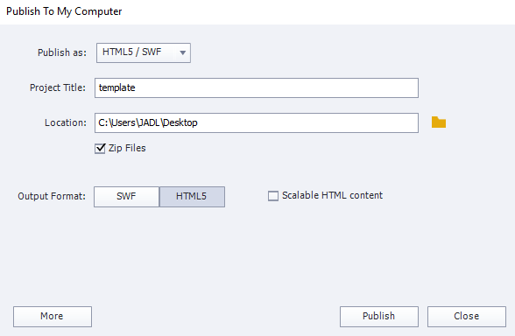

# Publishing Settings for Storyline

**Step 1: Enter Title, Description, and Folder Location**

On the Home tab of the Storyline ribbon, click the Publish button. (Or, from any other tab on the ribbon, you can click the small triangle under the Preview button, and then choose Publish.)

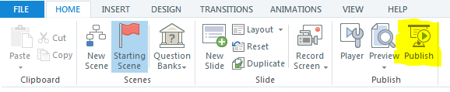

When the Publish window appears, click the LMS tab.

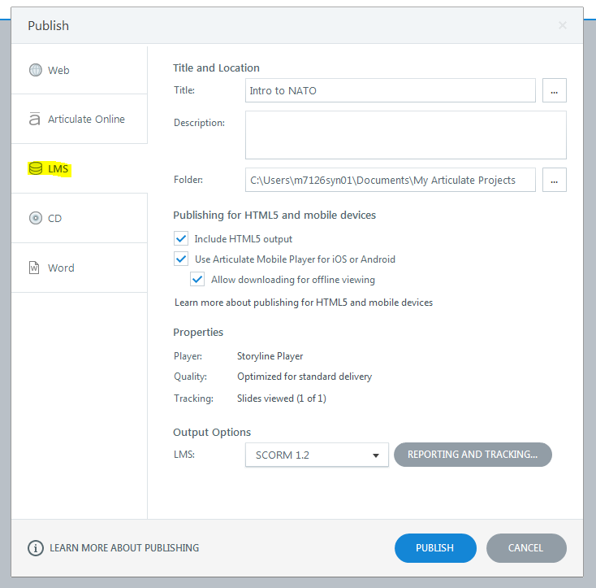

Check the text that appears in the Title field, and customize it if you like. This text defaults to the name of your Storyline file. If you change it, it'll change the title text that Storyline uses in the following places (but it won't change your actual file name):

The folder that Storyline creates to contain your published output. For example, if the Title field contains the words MSDS Course, Storyline creates a new folder on your hard drive called MSDS Course Output when you publish.

The browser title bar, when learners view your published course in a browser window.

The top bar of your course player, if you've opted to include the title as one of the player features.

Any screen in your LMS interface that contains titles of content items.

**Important!** Always publish to a local drive on your computer. Publishing to a network drive or a USB drive can create problems with your published output. After you publish your course to a local folder, you can upload the output to your LMS to test it.

**Step 2: Enter Additional Project Info for the Articulate Mobile Player (Optional)**

If learners will view content on iPads in the Articulate Mobile Player, you can customize additional information by clicking the ellipsis button (...) next to the Title field on the Publish window. The following Project Info window appears.

The Title and Description are the same as what you entered on the Publish window; change the text here if you'd like.

When learners browse content in their Articulate Mobile Player library, the thumbnail below the Title field will appear for this course. By default, Storyline uses an image of the first slide in your course, but you can choose a different image. Just click the blue slide title text. Then select a different course slide, or click Picture from File and choose an image.

Author, Email, Website, Duration, Date, and Version appear on the content information cards in the Articulate Mobile Player library.

The Identifier field is a unique string of characters assigned by Storyline. Your LMS uses it to identify your content. If you're republishing a course that's already in your LMS, don't change the value in this field.

Keywords aren't currently used. They'll be used in a future version of the Articulate Mobile Player app.

When you're finished customizing the project information, click OK to return to the Publish window.

Note these important facts about mobile output:

Tracking in the Articulate Mobile Player is only supported in learning management systems that support the Tin Can API specification.

If your LMS doesn't yet support Tin Can API and you need to track learners’ results, don't include the Articulate Mobile Player option when publishing (see the next section for details). Learners will need to view your course in a browser that supports Flash or HTML5, so it can communicate results to your LMS.

If your LMS doesn’t support Tin Can API but you don’t need tracking, you might still be able to deploy your content via your LMS for viewing in the Articulate Mobile Player. However, not all LMSs allow content to be viewed on a mobile app, so you’ll need to test this with your own LMS to confirm.

**Step 3: Choose HTML5 and/or Mobile Publishing (Optional)**

If some or all of your learners will access your content with an iPad or some other mobile device that doesn't support Flash, you can use the following options on the Publish window to make your course viewable in HTML5, the Articulate Mobile Player, or both. If you do this, be sure to also check out the info here so that your content looks and behaves the way you expect when viewed in a non-Flash environment.

Include HTML5 output: This prepares your course so that it's viewable as HTML5 content if a learner doesn't have the Flash player and they view your course in an HTML5-compatible browser. Keep in mind that not all browsers handle HTML5 content equally. This article identifies which browsers your learners should use if they need to view your course as HTML5 content.

Use Articulate Mobile Player on iPad: This prepares your course so that learners receive the best possible viewing experience on an iPad. If you mark this option, users may view the content through the free Articulate Mobile Player, which they'll be prompted to install the first time they attempt to use their iPad to view a Storyline-published course. (IMPORTANT: Tracking in the Articulate Mobile Player is only supported in learning management systems that support the Tin Can API specification. If tracking and reporting is crucial, but your LMS does not support the Tin Can API, do not mark this option. If your LMS doesn't support the Tin Can API but you don’t need tracking, you might still be able to deploy your Storyline content via your LMS for viewing on the Articulate Mobile Player. You’ll need to test this with your own LMS to confirm, since not all LMSs allow content to be viewed on a mobile app.)

Allow downloading for offline viewing: This box gives learners the option to download your course to their Articulate Mobile Player app, so they can view it offline later. However, offline viewing isn't currently supported for LMS content. An internet connection is required to view track content in an LMS.

**Step 4: Check Player Properties and Quality Settings**

The Properties section of the Publish window is where you can make any last-minute changes to your course player, or change the compression settings Storyline uses when publishing.

The Player field shows the name of the player that Storyline will use when you publish. (The player is the interface that users see when they view your course, and it can include things like player controls, resources, a glossary, a menu, and other features.) Click the player name if you'd like to make some final adjustments to your player or switch to a different player. If you need help choosing your player settings, see the tutorials here.

The Quality field allows you to control the compression settings Storyline uses for any audio, video, and pictures you've added to your course. The settings here default to whatever you used the last time you published a Storyline project. To change the quality settings, click the blue text and change any of the fields as noted below; then click OK.

Choose Standard if you want to use the default settings. If you mark this option, the values on the window revert back to their defaults (video quality of 5, audio bitrate of 48kbps, and image quality of 80%).

Choose Custom if you want to define your own quality settings. Then click and drag the slider on any of the three values to change the compression. Using higher values means higher-quality output, but also larger file sizes (which means longer download times). Lower values mean smaller file sizes and faster download times, but the visual and audio quality will be lower as well.

**Step 5: Choose Your Tracking and Reporting Preferences**

In the Properties section of the Publish window, click the Tracking field to open the following window, where you can choose your options for the way your LMS tracks and reports on your learners' progress:

Click the Reporting tab on the left edge of the window, and use the LMS selector to choose the standard to which you'd like to publish (ask your LMS administrator if you're not sure).

Complete the fields in the section called LMS Course Information and the section called LMS Lesson SCORM Information if it appears. (Again, ask your LMS administrator if you need help). Some important notes about the fields on this window:

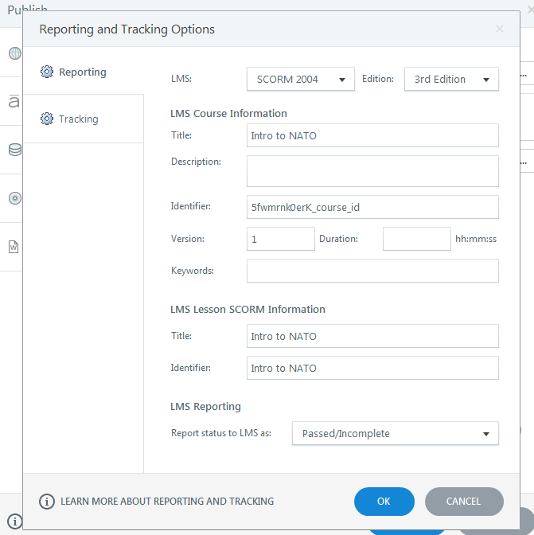

If you've chosen Tin Can API as your reporting specification, you'll see a field called Launch URL. Use this to enter the full URL of the .story.html file for your course if you plan to host the content on a server that's separate from your LMS. Typically you'd host your content on a server separate from your LMS if your LMS supports the Tin Can API but hasn't yet allowed private content authorization for mobile apps. Find out more here and here.

The Identifier field is a unique string of characters assigned by Storyline, and your LMS uses it to identify your content. If you're republishing a course that's already in your LMS and you plan to re-upload to your LMS, be sure not to change the value in this field.

If the window includes a section called LMS Reporting, use the selector to choose the wording you'd like to use when expressing learners' status with regard to this course.

Now click the Tracking tab on the left edge of the window and choose one of the following options:

Track using number of slides viewed: With this option, your LMS will determine whether a learner has passed or completed your course by monitoring the number of slides the learner has viewed. Use the selector to choose a number.

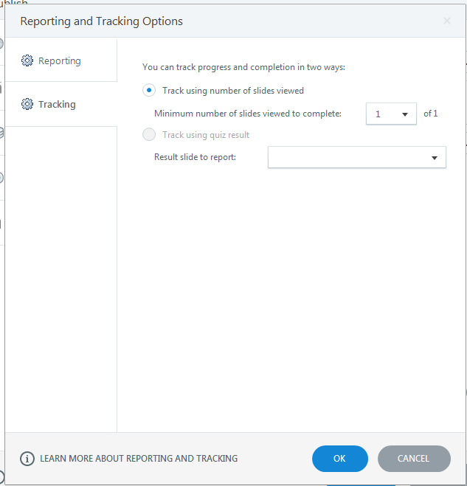

Track using quiz result: This option appears if your course includes a quiz result slide. Select this if you want your LMS to track learners' status based on their quiz results. If your course has multiple quizzes, you'll need to pick just one result slide to use for tracking. For more about result slides, see this tutorial. (Note: If you are using the Tin Can API, the quiz you select here is used to report the overall course score, but individual quiz questions and other quiz result slides will also be reported.)

Click OK when you're finished setting up your tracking and reporting preferences.

**Step 6: Publish**

When you're finished choosing your options on the Publish window, just click the Publish button.

Storyline creates your published output in the location you specified. When publishing is complete, you'll see the following pop-up, and you can choose whichever option suits you:

View Project: This launches your course in your web browser so you can take a look at your output. If you want to test your published course, though, it's best not to do it this way. Since your published output was created specifically for use with an LMS, you should instead upload your course to your LMS and test it from there, to make sure it behaves as expected in the environment where you plan to use it.

Email: This opens up a new email message with a zipped file of your published output attached. This might be helpful if your LMS administrator will upload your course for you, and you need to send him or her the published output for upload.

FTP: This pops up a window where you can enter your FTP credentials and transfer your output to a website (which isn't something you'd typically do if you've published for LMS).

ZIP: This creates a zipped file of your output in the location you specified on the Publish window. For LMS users, this is the most common choice, because then you can easily upload your entire zipped course to your LMS.

Open Folder: This opens a file viewer where you can see the files Storyline just created. There will be several folders and files which are needed to play your course. If your LMS requires that you identify a single launch file once you've uploaded your content, the file to point to is index_lms.html.

What Do I Do with My Published Files?

Now that you've published, it's time to upload your content to your learning management system. The steps for this are slightly different for each LMS. Ask your LMS administrator if you need help with the specifics of uploading, launching, or tracking your course.

If You Publish for HTML5 and/or the Articulate Mobile Player...

When learners launch your course, they'll automatically see the right type of content based on the device and browser they're using:

They'll see the Flash content if their browser supports it.

If they're using an iPad, and if you chose the Articulate Mobile Player option when you published, they'll see a launch page that allows them to view the course in the Articulate Mobile Player. (And if they don't have the player installed on their iPad yet, they'll see an option to install it.)

If they're using an iPad and you didn't choose the mobile player option when you published, but you did choose HTML5, they'll see the HTML5 output.

If they're using some other non-Flash compatible browser and you chose to publish for HTML5, they'll see the HTML5 output.

[Reference: Articulate Community website](https://community.articulate.com/series/articulate-storyline-1/articles/publishing-a-project-for-lms) – accessed 23 Feb 2018

# Publishing Settings for Rise

Within your course> top right menu click **Export**

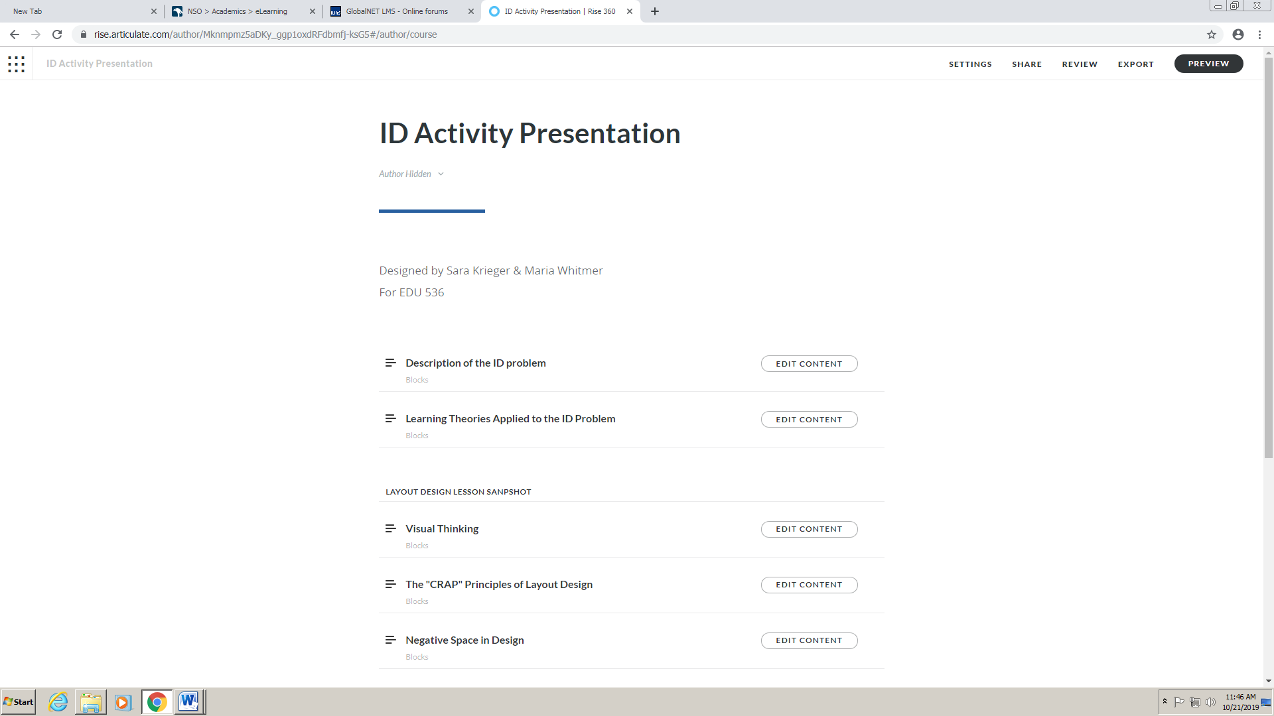

The window below will open, where you select LMS as the export type. For tracking reasons, select LMS as SCORM 1.2.

Then for Tracking, select either track using course completion (no graded assessment) or track using Quiz results (only enabled when you have set-up a graded quiz). Click Export and a zip package will download to your computer.

**Important Before Uploading to LMS:**

Rename the downloaded SCORM Package with a shorter name

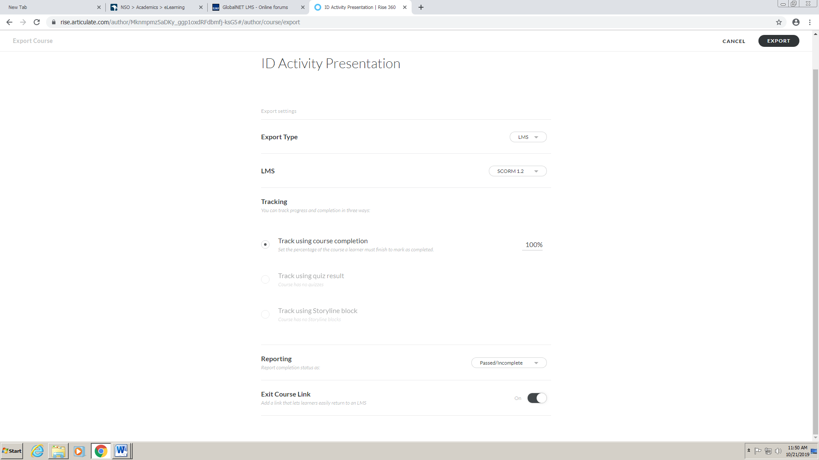

# Upload in LMS

To upload a SCORM /AICC Learning Module:

1.Open the drop-down menu "Add New Item" in the top right corner of a Repository view and choose the option „Learning Module SCORM“.

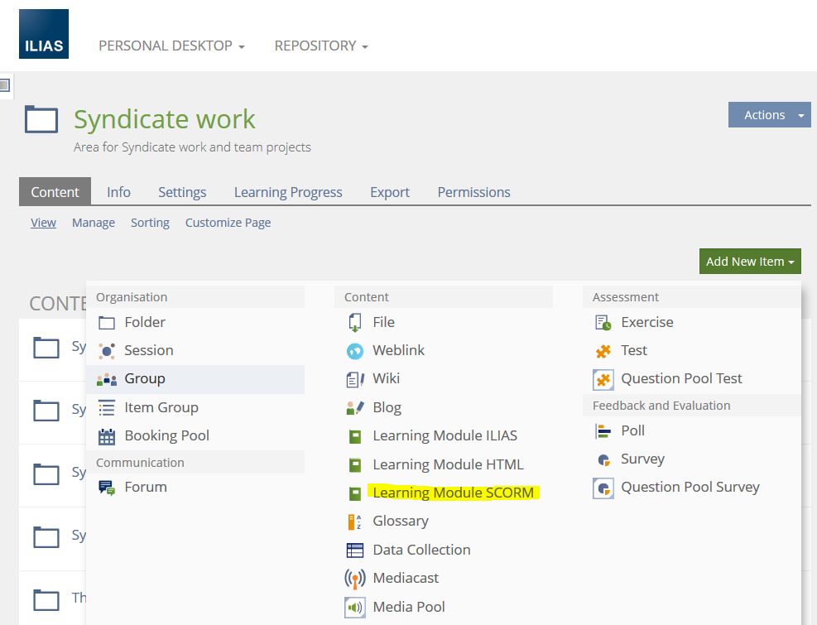

2.In the field appearing then, you can upload a new SCORM learning module from your local computer in the upper section "Option 1: Import SCORM Package".

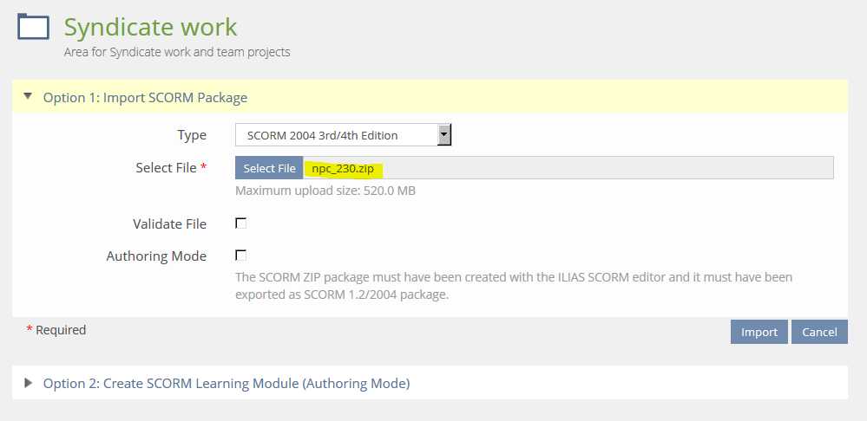

3.Finally, click "Import".

4. don’t forget to check, Online box in Settings and “Save".

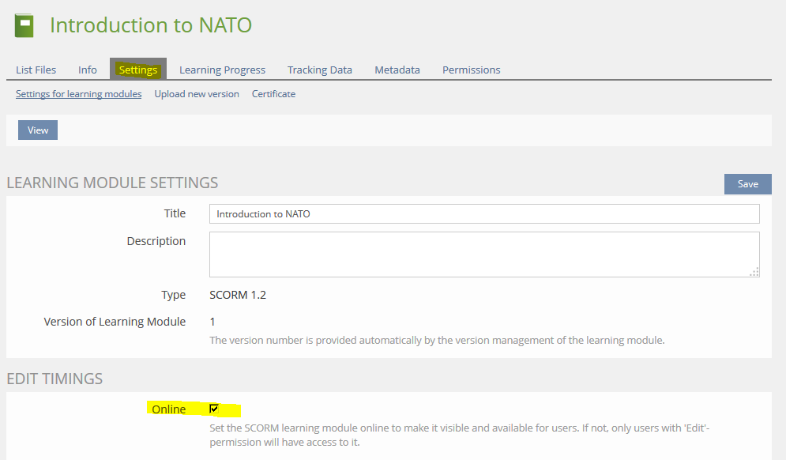

Reference NATO School GlobalNET LMS accessed 23 Feb 2018